**Project 12 Ultrasonic Following Smart Car**

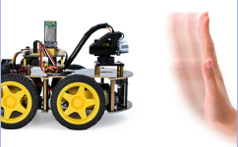

**1.Description**

In this project, we will look to detect the distance between the 4WD smart car and the obstacles ahead through an ultrasonic sensor to drive two motors in a way that make the car move and make the 8*8 LED board show a smile facial pattern.

**2.Flow Chart**

|  |  |  |
| --- | --- | --- |
| Detection | Measured distance of front obstacles | distance（unit：cm） |
| Setting | 8*16 LED board shows a smile pattern. | |
| Set servo to 90° | |
| Condition | distance≥20 and distance≤50 | |
| Status | Go forward | |
| Condition | distance＞10 and distance＜20 | |
| distance＞50 | |
| Condition | stop | |
| Condition | distance≤10 | |
| Condition | Go back | |



**3.Wiring Diagram**

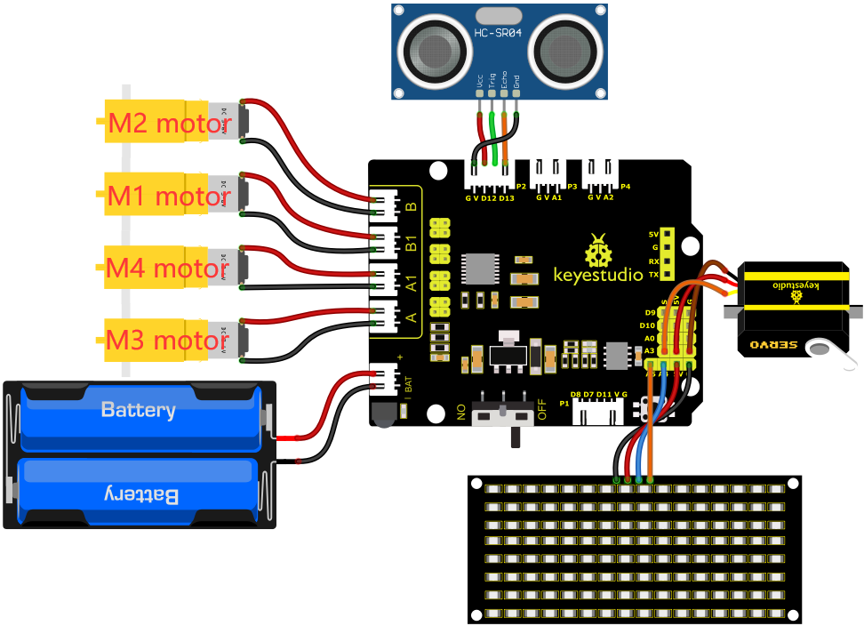

Wiring up：

1. GND, VCC, SDA and SCL of the 8*8 LED board are connected to G（GND), V（VCC), A4 and A5 of the expansion board.

2. VCC, Trig, Echo and Gnd of the ultrasonic sensor are connected to 5V(V), D12(S), D13(S) and Gnd(G)

3. The servo is connected to G, V and A3. The brown wire is interfaced with Gnd(G), the red wire is interfaced with 5V(V) and the orange wire is interfaced with A3.

4. The power is connected to the BAT port

**4.Test Code**

You can drag blocks to edit. Blocks listed below are for your reference

1. 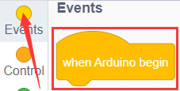
2. 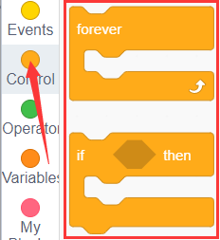
3. 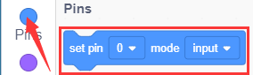
4. 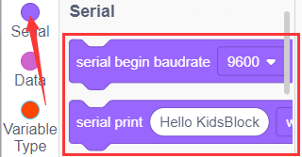
5. 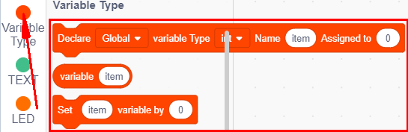
6. 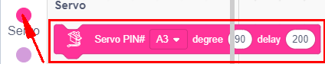
7. 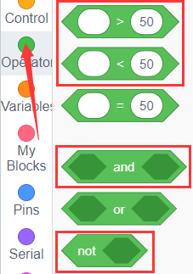
8. 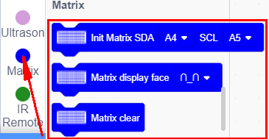
9. 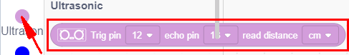
10. 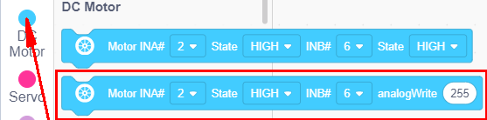

Complete Test Code

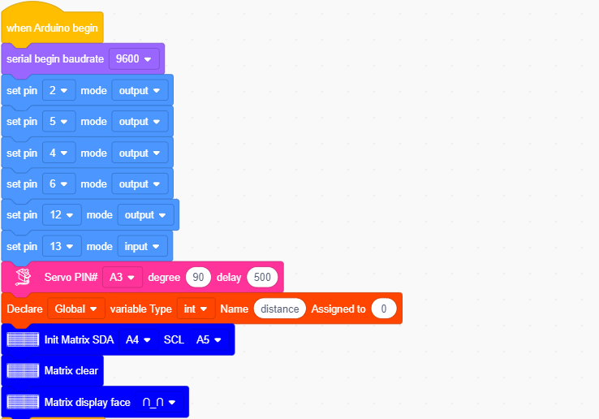

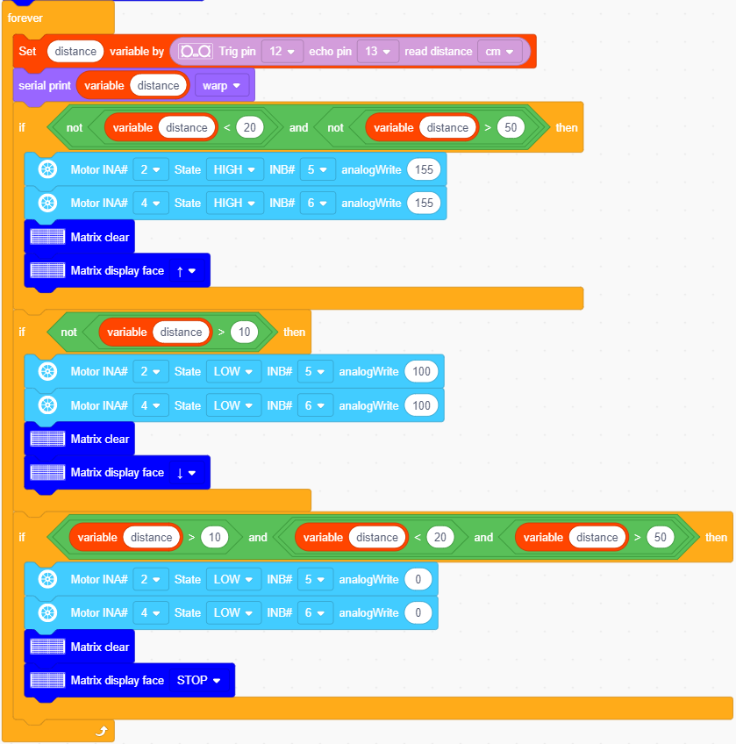

**5.Test Result**

After successfully uploading the code to the V4.0 board, connect the wirings according to the wiring diagram, power on the external power then turn the DIP switch to ON. Set the servo to 90°，the smart car will move with the obstacles and the 8X16 LED board will show“smile”.